# Pointers

The pointer in C language is a variable which stores the address of another variable. This variable can be of type int, char, array, function, or any other pointer. The size of the pointer depends on the architecture. However, in 32-bit architecture the size of a pointer is 2 byte.

Consider the following example to define a pointer which stores the address of an integer.

1. **int** n = 10;
2. **int**\* p = &n; // Variable p of type pointer is pointing to the address of the variable n of type integer.

## Declaring a pointer

The pointer in c language can be declared using * (asterisk symbol). It is also known as indirection pointer used to dereference a pointer.

1. **int** *a;//pointer to int
2. **char** *c;//pointer to char

**Using a Pointer:**

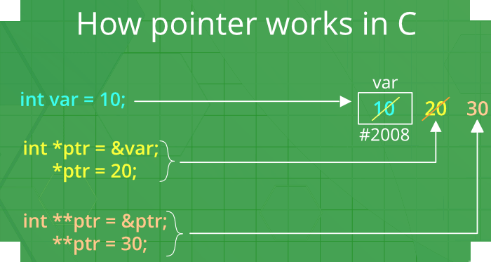

## Pointer Example

An example of using pointers to print the address and value is given below.

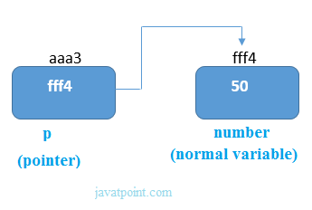

## As you can see in the above figure, pointer variable stores the address of number variable, i.e., fff4. The value of number variable is 50. But the address of pointer variable p is aaa3.

## NULL Pointer

A pointer that is not assigned any value but NULL is known as the NULL pointer. If you don't have any address to be specified in the pointer at the time of declaration, you can assign NULL value. It will provide a better approach.

int *p=NULL;

In the most libraries, the value of the pointer is 0 (zero).